Image | 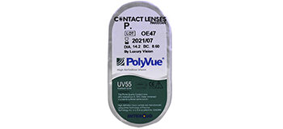
Brand | TOM FORD
Model Name
Price
PRODUCT DETAILS

